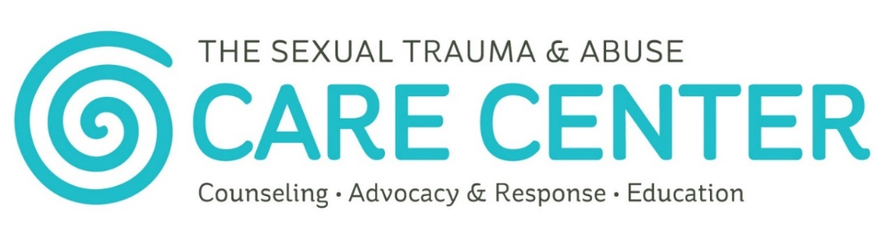

The Sexual Trauma & Abuse Care Center’s mission is to promote a culture of consent while providing 24/7 support to anyone affected by sexual trauma and abuse in Douglas, Franklin, and Jefferson Counties.
- Counseling: Trauma-focused individual therapy & support groups
- Advocacy & Response: 24/7 support line, medical advocacy during forensic exams, assistance with police reports & court proceedings.
- Education: Youth & adult sexual assault and consent education, awareness & professional trainings.

Contact:
24/7 Anonymous & Confidential Support is available by calling 785-843-8985
www.stacarecenter.org

Main Office:
708 W 9th Street, Suite 105, Lawrence, KS 66044 (Walk-ins welcome)
Ottawa Office:
114 W 2nd Street, Ottawa, KS 66067
(By appointment only)

Oskaloosa Office:
100 Washington Street, Oskaloosa, KS 66066
(By appointment only)

Facebook: facebook.com/stacarecenter
Twitter: @stacarecenter
Instagram: @stacarecenter

What is Consent?
Consent is where you feel safe and comfortable to agree and say YES without fear or pressure. If you aren’t being listened to or feel scared, that is NOT consent. Consent is ongoing (not just a one-time question) and something that is REQUIRED for all sexual and romantic relationships.

What is Sexual Trauma & Abuse?
Sexual trauma & abuse is any sexual activity that is without consent. This can be a one-time event or something that goes on for years. It can happen to children and teens. Adults and youth can be perpetrators. When any adult who engages in sexual activity with someone under the age of 19, it is sexual abuse. Sexual trauma & abuse can be unwanted touching, looking, showing, or any unwanted sexual activity. It can also happen when someone sends you unwanted nude pictures or shares your nude pictures without your permission.
Sexual Trauma & Abuse is NEVER the Victim’s Fault!

Reactions & Emotions
There isn’t one way that people feel after experiencing sexual trauma or abuse. Every emotion is valid and real. Here are some examples of emotions or reactions that a victim might have:
- Anxiety, fear, depression
- Physical health symptoms
- Flashbacks, intrusive, and distressing memories of the violence
- Disorientation and difficulty concentrating
- Self-blame, guilt, and shame
- “Shutting down”, avoidance, or emotional numbing
Coping Responses: Everyone responds differently to trauma. Survivors may use a variety of coping mechanisms including: alcohol/drug use, social isolation, anger and aggressive behavior toward others, avoidance, cutting, disordered eating, high-risk sexual behaviors, etc.
It’s okay for survivors to have happy experiences! Everyone reacts differently and it’s okay for survivors of trauma to still experience joy and happiness. This might be seen as avoidance by others, but every emotion the survivor experiences is real and valid.

You Might Feel…
- Really scared, sad, or confused because someone you know and trust hurt you.
- Unheard or not believed when you talk to adults, especially if the person who abused you has a lot of authority.
- Unheard or not believed when you talk to your friends, especially if the person who abused you is “cool” or well-liked.
- Bullied after talking about your experience if you are not believed by your peers.
- Forced to continue to go to school with, be taught or coached by, or live with the person who abused you while trying to get the support you need after an assault.
- Punished by your parents, the police or courts, or school authorities after talking about your assault if you were in circumstances that were “breaking the rules” when someone assaulted you.
- Unheard, not believed, and discredited because of your age.
- Unable to access therapy, medical care, or support without your legal guardian’s assistance or permission.
- Afraid to disclose abuse to a safe adult because they will make a child abuse report that could result in you being removed from your home and placed in foster care.
- Not in control of your personal information and how it is used and not able to make decisions for yourself about how to proceed with seeking support.

The Care Center can help! (Contact information is on Page 2.)

The Sexual Trauma & Abuse Care Center does not discriminate on the basis on race, color, religion, sexual orientation, gender identity, national origin, age, disability, genetic information, marital status, amnesty or status as a covered veteran in accordance with applicable federal, state and local laws.
This agency, along with the Office of the Attorney General, is interested in improving services available to victims in Kansas. If you have any suggestions or complaints about services provided to you and wish to share them with the office of the Attorney General, please call 1-800-828-9745 or complete the survey forms available at ag.ks.gov/docs/forms/20120215victim-service-suggestion-form.pdf?svrsn=2.
This grant project is supported by subgrant number 15-VAWA-04 awarded through the Kansas Governor’s Grants Program for the STOP Formula Grant Program. The opinions, findings, conclusions, or recommendations expressed in this publication, program, or exhibition are those of the author(s) and do not necessarily reflect the views of the Office of the Kansas Governor or the U.S. Department of Justice, Office of Violence Against Women.

