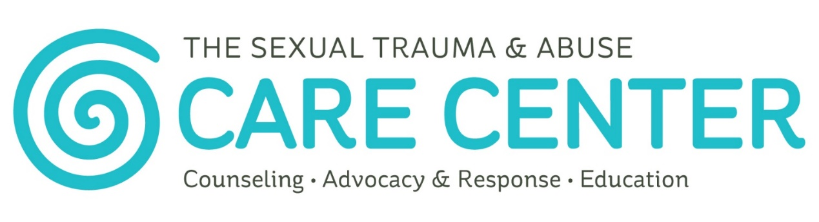
24/7 Support: 785-843-8985
The Sexual Trauma & Abuse Care Center’s mission is to promote a culture of consent while providing 24/7 support to everyone affected by sexual trauma and abuse in Douglas, Franklin, and Jefferson Counties. Services are free & confidential to people of all ages & genders.

Contact:
www.stacarecenter.org
24/7: 785-843-8985
Fax: 785-371-9568

Main Office:
708 W 9th Street, Suite 105, Lawrence, KS 66044 (Walk-ins welcome)
Ottawa Office:
401 S Main Street, Suite 8 Ottawa, KS 66067
(By appointment only)

Oskaloosa Office:
100 Washington Street, Oskaloosa, KS 66066
(By appointment only)

Facebook: facebook.com/stacarecenter
Twitter: @stacarecenter

The Care Center Services
- Counseling
- Individual Therapy: Trauma-focused counseling is available for people affected by sexual trauma & abuse. The Care Center counselors offer therapy to individuals as well as their family, friends, and loved ones.

- Support Groups: A variety of ongoing support groups to promote healing, develop skills, and create a community of support. Visit our website or give us a call to find the support group that is right for you.

- Advocacy & Response
- 24/7 Support Line: Trained advocates are ready to listen and help.
- Medical Advocacy: Information & support during evidence collection exams & ongoing medical needs.
- Court & Law Enforcement: Assistance with police reports, protection orders & other court proceedings.

- Education
- Engaging & innovative educational opportunities: Educators at The Care Center offer a variety of presentations & trainings with topics ranging from sexual trauma & abuse, consent, rape culture & more. Age-appropriate programs are available to youth of all ages.

The Sexual Trauma & Abuse Care Center does not discriminate on the basis on race, color, religion, sexual orientation, gender identity, national origin, age, disability, genetic information, marital status, amnesty or status as a covered veteran in accordance with applicable federal, state and local laws.
This agency, along with the Office of the Attorney General, is interested in improving services available to victims in Kansas. If you have any suggestions or complaints about services provided to you and wish to share them with the office of the Attorney General, please call 1-800-828-9745 or complete the survey forms available at ag.ks.gov/docs/forms/20120215victim-service-suggestion-form.pdf?svrsn=2.
This grant project is supported by subgrant number 16-VOCA-13 awarded through the Federal Office for Victims of Crime as administered by the Kansas Governor’s Grants Program. The opinions, findings, conclusions, or recommendations expressed in this publication, program, or exhibition are those of the author(s) and do not necessarily reflect the views of the Office of the Kansas Governor or the U.S. Department of Justice.

